Abi Shilon  abi@cti-israel.com  www.cti-israel.com  www.shilon.com | 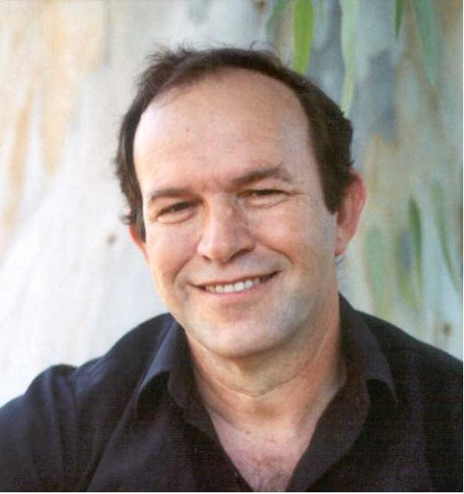

Abi's has more than 25 years of experience in the hi-tech industry (Tadiran, ECI, Harmonic and others) . He started as an electronics and software engineer in the Telecom industry and proceeded to management roles in R&D and Marketing departments with a lot of experience in team management and multinational interaction. In 2003 Abi also graduated cum laude an MBA program.
Starting at 2002 Abi started training as a Co-Active coach with the Coaches Training Institute ( www.thecoaches.com ) in California and in the UK. Since 2003 Abi represents CTI in Israel . Apart from producing intensive coach training courses Abi coaches individuals, managers and teams.
Abi is also a graduate of a year long Co-Active Leadership intensive training in California ( www.thecoaches.com/leadership ) . Since 2007, Abi Joined international CTI's faculty and started leading coach training courses for CTI over the world.

Abi lives in Karkur, father of 3 and grandfather of one, loves and plays music, interested in meditation and eastern philosophies and reads fiction for pleasure.
His real passion is witnessing people evolve and grow beyond self belief, personally and professionally.

